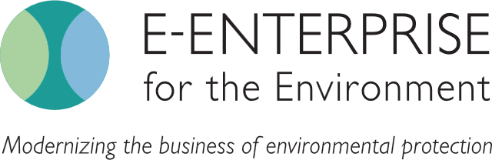

# SOFTWARE LICENSING RESOURCES FOR TRIBAL ENVIRONMENTAL PROFESSIONALS

Developing planning tools to support tribal software investments and long-term costs

Project Summary

As tribal environmental programs incorporate more IT tools into their work, tribes need to plan to cover longer-term software operations and maintenance costs, including the license renewals and associated fees. This project is working through E-Enterprise to compile, create, and share best practices and resources to help plan for and support these investments and long-term costs.

Project Leads

Jessica Snyder

U.S. EPA Office of E-Enterprise, Office of the Chief Financial Officer, [snyder.jessica@epa.gov](mailto:snyder.jessica@epa.gov),   
(202) 340-8395

Resources

[Software Licensing Frequently Asked Questions (FAQ): A Resource for Tribal Environmental Professionals](https://www.epa.gov/system/files/documents/2022-12/tribal-software-faq.pdf)

[Software Procurement Roadmap for Tribes](https://www.epa.gov/system/files/documents/2022-12/software-procurement-roadmap-for-tribes.pdf)

## Challenge

Tribal environmental professionals use tools and technology to perform their work and support the implementation of environmental programs. Software is a necessity and an important component in modernizing and streamlining work. However, buying software is not a one-time purchase. Like most technology, software requires an upfront investment and has long-term expenses, including software license renewals, often referred to as operations and maintenance. Tribes can use federal grant dollars to support bot up-front costs and tribal access to continuous resources to maintain software investments however, those longer-term costs need to be incorporated into the grant work planning process.

## Benefits

* Shared best practices and solutions related to obtaining and supporting software.
* Improved workplans for longer-term programmatic grants.
* Shared many low or no-cost software options.
* Shared information about federal agencies and organizations that provide software technical assistance and training for tribes who need it.

## Accomplishments

* Developed [the Software Licensing Frequently Asked Questions](https://www.epa.gov/system/files/documents/2022-12/tribal-software-faq.pdf) (FAQ) for Tribal Environmental Professionals, a resource that addresses common issues or questions that tribes experience when they are purchasing software. This document is intended to provide basic information such as terminology and definitions, information on using grants to support software needs, and approaches for reducing costs and finding training.
* Developed a [Software Procurement Roadmap](https://www.epa.gov/system/files/documents/2022-12/software-procurement-roadmap-for-tribes.pdf), a resource that crosswalks the steps to procuring software against the steps of the grant life cycle. This document is intended to help tribal environmental professionals who may need basic information about the software procurement process and how it aligns with the EPA grants process.

## What’s Next?

Launch a communications roadshow to share the workgroup outcomes with emphasis on the two available resources (*listed under accomplishments and resources*) at tribal meetings, including Regional Tribal Operations Committees, tribal conferences, and trainings.